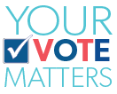

- What is your top priority for improving health care?

- What actions do you propose to support Missouri’s hospitals and rural health care throughout the COVID-19 pandemic?
- If elected, how will you ensure Medicaid expansion, as approved by voters on the primary election ballot, is implemented by July 2021?

- What role should state government play in promoting an adequate supply of health care practitioners in our state?
- What should state government do to protect the jobs and other economic benefits hospitals bring to their communities?

