Need to Know: East Covid19 Clinical Line & Testing Center
General Info
Why is Mercy setting up a phone line & testing center?
Mercy is developing processes to limit exposure of our coworkers and patients to Covid19. One tactic is to keep Patients Under Investigation (PUI) out of the hospitals if they do not require admission. The phone line and testing centers are to support providers in their decision making for testing and need for transfer/admission (managed by call center in the Mercy East HUB). The second goal is to provide information and screening to the public (managed by Nurse on Call)
What is my role?
Call Center: will process calls related to providers with questions around “Should I test may patient?”. Algorithms are in place to guide the discussion. Calls requesting transfer/direct admit will be handed off to the East Regional Transfer Center RN.
Testing Center: A drive through testing center (swab) will be set up off site. Patients will be scheduled for the testing center via referral from the call center. You will collect and label the swabs
How do I schedule?
- Go to the Mercy East Transfer Center HUB on Baggott Street East Transfer Center HUB
- Click on the green hyperlink to open the schedule (be sure to select either Call Center or Testing Center)
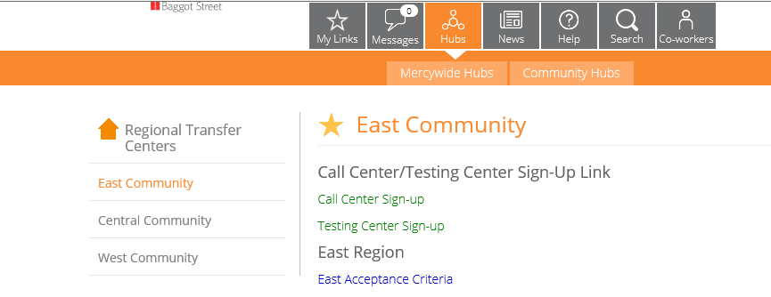
- The schedule will open. Click on “Edit Workbook” in upper right corner and select “Edit in Browser”
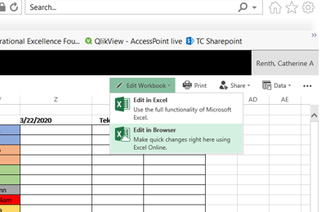
- Find the date and time you want to work and enter your information
- Close the excel clicking the X on the header

Where will I be working?
Call Center: You will work in the East Throughput HUB on the 6th floor of the STL heart hospital
Testing Center: Testing Center will be located on the Mercy Virtual Care Lot: 15740 S Outer Forty Rd, Chesterfield, MO 63017
How will I be paid?
Hourly coworkers will be paid overtime in accordance with overtime policy
Exempt: HR identifying some type of bonus pay for shifts above your FTE-details to follow
How do I call in if I’m sick?
Work with your department leader to secure coverage for your absence. Call the Nursing Logistics at 314-251-6260 to report the schedule change.
How will I be oriented?
Review the document packet prior to your first shift. Report 30 minutes before the start of your first shift for orientation from the off going coworker
Can I work both areas?
We ask you select one area so you are familiar with the workflows. If you do not have a preference, review both schedules to see which team has the most openings. We will review the schedule several times a day for balance and may ask you to switch days/teams as necessary.
Am I limited to a 4 hour shift?
You may choose to work 4 or 8 hours to best fit your needs.
Call Center Specifics
How do I get badge access for the door of the HUB? Once your name is on the schedule, door access will be requested.
What is the phone number for the call center? 314-251-0500
Training Materials: Review the information below for screening criteria and common questions callers may ask

CRITERIA for COVID-19 Testing
Patient Screening (CDC)
Patients who meet the following criteria should be evaluated as a person under investigation (PUI) in association with the outbreak of COVID-19 https://www.cdc.gov/coronavirus/COVID-19/clinical-criteria.html: Criteria is intended to serve as guidance for evaluation
Click link for list of countries: https://wwwnc.cdc.gov/travel/notices/warning/coronavirus-europe

Clinical Features | AND | Epidemiologic Risk
Fever¹ and/or signs/symptoms of lower respiratory illness (e.g. cough or shortness of breath) | AND | Any person, including healthcare workers², who has had close contact³ with a laboratory-confirmed⁴ COVID-19 patient within 14 days of symptom onset
Fever¹ and/or symptoms of a lower respiratory illness (e.g., cough or shortness of breath) requiring hospitalization | AND | A history of travel from **affected geographic areas ⁵ (International-China, Iran, Italy, Japan, South Korea, most of Europe*, USA-King County/Seattle, Washington, California, New York) within 14 days of symptom onset
Fever¹ with severe acute lower respiratory illness (e.g., pneumonia, ARDS) requiring hospitalization and without alternative explanatory diagnosis (e.g., influenza)⁶ | AND | No source of exposure has been identified
Fever1 and signs/symptoms of a lower respiratory illness (e.g., cough or shortness of breath) without alternative explanatory diagnosis (e.g., influenza), not hospitalized or considered severe | AND | A history of travel from affected geographic areas5 (see below) within  14 days of symptom onset
*Click link for list of countries: https://wwwnc.cdc.gov/travel/notices/warning/coronavirus-europe
** https://www.cdc.gov/coronavirus/2019-ncov/travelers/after-travel-precautions.html
European Countries:
Austria | Germany | Lithuania | Slovakia | Vatican City
Belgium | Greece | Luxembourg | Slovenia
Czech Republic | Hungary | Malta | Spain
Denmark | Iceland | Netherlands | Sweden
Estonia | Italy | Norway | Switzerland
Finland | Latvia | Poland | Monaco
France | Liechtenstein | Portugal | San Marino

1Fever may be subjective or confirmed
²For healthcare personnel, testing may be considered if there has been exposure to a person with suspected COVID-19 without laboratory confirmation. Because of their often extensive and close contact with vulnerable patients in healthcare settings, even mild signs and symptoms (e.g., sore throat) of COVID-19 should be evaluated among potentially exposed healthcare personnel.
³Close contact is defined as—
a) being within approximately 6 feet (2 meters) of a COVID-19 case for a prolonged period of time; close contact can occur while caring for, living with, visiting, or sharing a healthcare waiting area or room with a COVID-19 case
– or –
b) having direct contact with infectious secretions of a COVID-19 case (e.g., being coughed on)
If such contact occurs while not wearing recommended personal protective equipment or PPE (e.g., gowns, gloves, NIOSH-certified disposable N95 respirator, eye protection), criteria for PUI consideration are met.
Additional information is available in CDC’s updated Interim Infection Prevention and Control Recommendations for Patients with Confirmed COVID-19 or Persons Under Investigation for COVID-19 in Healthcare Settings.
Data to inform the definition of close contact are limited. Considerations when assessing close contact include the duration of exposure (e.g., longer exposure time likely increases exposure risk) and the clinical symptoms of the person with COVID-19 (e.g., coughing likely increases exposure risk as does exposure to a severely ill patient). Special consideration should be given to healthcare personnel exposed in healthcare settings as described in CDC’s Interim U.S. Guidance for Risk Assessment and Public Health Management of Healthcare Personnel with Potential Exposure in a Healthcare Setting to Patients with COVID-19.
⁴Documentation of laboratory-confirmation of COVID-19 may not be possible for travelers or persons caring for COVID-19 patients in other countries.
⁵Affected areas are defined as geographic regions where sustained community transmission has been identified. Relevant affected areas will be defined as a country with at least a CDC Level 2 Travel Health Notice. See all COVID-19 Travel Health Notices.

I want to get tested. Where can I go to do that? Tell me why you are needing testing. Testing is only advised if a person is sick and they have had travelled to specific countries or contact with a patient identified with coronavirus. Testing without being ill will have false negative results.

CALLER DOES NOT MEET TESTING CRITERIA who may have mild symptoms
If you’re just mildly ill, stay home and contact your health care provider by phone or via MyMercy for guidance as you normally would when sick.

What are the symptoms?

People with COVID-19 do not have a runny nose or nasal congestion. Symptoms to be aware of include:
- 100.4 fever or higher - 90% will have fever.
- Dry cough - 70% will have a dry cough.
- Shortness of breath – for those who become more acutely ill.

Caller meets criteria for testing:
East Region: Refer caller to COVID-19 Clinical Support Line 314-251-0500
There are also state health department call center numbers we can share:
Arkansas: 1-800-803-7847
Missouri: 1-877-435-8411
Oklahoma: 1-877-215-8336
Kansas: Right now, Kansas does not have a public number available
Illinois: 1-800-889-3931

How do I prevent getting sick?
Wash hands frequently
Keep hands away from face
Avoid crowds

Who is at highest risk for getting COVID-19?
If you are at higher risk for serious illness from COVID-19 because of your age or because you have a serious long-term health problem, it is extra important for you to take actions to reduce your risk of getting sick with the disease.
- Have supplies on hand
  - consider extra necessary medications to have on hand in case there is an outbreak of COVID-19 in your community and you need to stay home for a prolonged period of time.
  - If you cannot get extra medications, consider using mail-order for medications.
  - Be sure you have over-the-counter medicines and medical supplies (tissues, etc.) to treat fever and other symptoms. Most people will be able to recover from COVID-19 at home.
  - Have enough household items and groceries on hand so that you will be prepared to stay at home for a period of time.
- Take everyday precautions
  - Avoid close contact with people who are sick
  - Take everyday preventive actions
    - Clean your hands often
    - Wash your hands often with soap and water for at least 20 seconds, especially after blowing your nose, coughing, or sneezing, or having been in a public place.
    - If soap and water are not available, use a hand sanitizer that contains at least 60% alcohol.
    - To the extent possible, avoid touching high-touch surfaces in public places – elevator buttons, door handles, handrails, handshaking with people, etc. Use a tissue or your sleeve to cover your hand or finger if you must touch something.
    - Wash your hands after touching surfaces in public places.
    - Avoid touching your face, nose, eyes, etc.
    - Clean and disinfect your home to remove germs: practice routine cleaning of frequently touched surfaces (for example: tables, doorknobs, light switches, handles, desks, toilets, faucets, sinks & cell phones)
    - Avoid crowds, especially in poorly ventilated spaces. Your risk of exposure to respiratory viruses like COVID-19 may increase in crowded, closed-in settings with little air circulation if there are people in the crowd who are sick.
    - Avoid all non-essential travel including plane trips, and especially avoid embarking on cruise ships.
- If COVID-19 is spreading in your community, take extra measures to put distance between yourself and other people to further reduce your risk of being exposed to this new virus.
  - Stay home as much as possible.
    - Consider ways of getting food brought to your house through family, social, or commercial networks
- Have a plan for if you get sick:
  - Consult with your health care provider for more information about monitoring your health for symptoms suggestive of COVID-19.
  - Stay in touch with others by phone or email. You may need to ask for help from friends, family, neighbors, community health workers, etc. if you become sick.
  - Determine who can provide you with care if your caregiver gets sick
Who is at highest risk for getting COVID-19?
If you are at higher risk for serious illness from COVID-19 because of your age or because you have a serious long-term health problem, it is extra important for you to take actions to reduce your risk of getting sick with the disease.
- Have supplies on hand
  - consider extra necessary medications to have on hand in case there is an outbreak of COVID-19 in your community and you need to stay home for a prolonged period of time.
  - If you cannot get extra medications, consider using mail-order for medications.
  - Be sure you have over-the-counter medicines and medical supplies (tissues, etc.) to treat fever and other symptoms. Most people will be able to recover from COVID-19 at home.
  - Have enough household items and groceries on hand so that you will be prepared to stay at home for a period of time.
- Take everyday precautions
  - Avoid close contact with people who are sick
  - Take everyday preventive actions
    - Clean your hands often
    - Wash your hands often with soap and water for at least 20 seconds, especially after blowing your nose, coughing, or sneezing, or having been in a public place.
    - If soap and water are not available, use a hand sanitizer that contains at least 60% alcohol.
    - To the extent possible, avoid touching high-touch surfaces in public places – elevator buttons, door handles, handrails, handshaking with people, etc. Use a tissue or your sleeve to cover your hand or finger if you must touch something.
    - Wash your hands after touching surfaces in public places.
    - Avoid touching your face, nose, eyes, etc.
    - Clean and disinfect your home to remove germs: practice routine cleaning of frequently touched surfaces (for example: tables, doorknobs, light switches, handles, desks, toilets, faucets, sinks & cell phones)
    - Avoid crowds, especially in poorly ventilated spaces. Your risk of exposure to respiratory viruses like COVID-19 may increase in crowded, closed-in settings with little air circulation if there are people in the crowd who are sick.
    - Avoid all non-essential travel including plane trips, and especially avoid embarking on cruise ships.
- If COVID-19 is spreading in your community, take extra measures to put distance between yourself and other people to further reduce your risk of being exposed to this new virus.
  - Stay home as much as possible.
    - Consider ways of getting food brought to your house through family, social, or commercial networks
- Have a plan for if you get sick:
  - Consult with your health care provider for more information about monitoring your health for symptoms suggestive of COVID-19.
  - Stay in touch with others by phone or email. You may need to ask for help from friends, family, neighbors, community health workers, etc. if you become sick.
  - Determine who can provide you with care if your caregiver gets sick

Talking Points for Call Takers

What is the best way to protect myself and my family? Good hand hygiene is crucial. Wash your hands frequently with soap and water or use a hand sanitizer with at least 60% alcohol content.
Stay 6 feet away from anyone who is coughing or sneezing.
Avoid shaking hands.
If you’re sick, stay home. You should be fever free for 24 hours before returning to your regular activities.
If you work in an area that has frequent public contact (like a reception desk), use a disinfecting wipe to clean your area often.
I want to get tested. Where can I go to do that?
- St. Louis answer: Testing is only valid for those who have respiratory symptoms (fever, cough or shortness of breath). Mercy is working to set up a specific screening site in the St. Louis area for those who meet the symptom and exposure criteria.
Not everyone should be tested. Testing prior to the appearance of symptoms can result in a false negative.
Missouri health officials are still reviewing each potential case and directing who should get tested. Right now, they’re limiting testing to those who’ve recently traveled to the countries of concern: China, Iran, Italy, South Korea, Japan or to King County/Seattle, Washington or to those who have come into close contact with someone who has tested positive.
- In other parts of Missouri: Testing is only valid for those who have respiratory symptoms (fever, cough or shortness of breath). Not everyone should be tested. Testing prior to the appearance of symptoms can result in a false negative.
Missouri health officials are still reviewing each potential case and directing who should get tested. Right now, they’re limiting testing to those who’ve recently traveled to the countries of concern: China, Iran, Italy, South Korea, Japan or to King County/Seattle, Washington or to those who have come into close contact with someone who has tested positive. If we start to have patients in your area who test positive, we may set up a separate screening center. We will let everyone know.
- In Arkansas: Testing is only valid for those who have respiratory symptoms (fever, cough or shortness of breath). Not everyone should be tested. Testing prior to the appearance of symptoms can result in a false negative.
- In Oklahoma: Testing is only valid for those who have respiratory symptoms (fever, cough or shortness of breath). Not everyone should be tested. Testing prior to the appearance of symptoms can result in a false negative.
- In Kansas: Testing is only valid for those who have respiratory symptoms (fever, cough or shortness of breath). Not everyone should be tested. Testing prior to the appearance of symptoms can result in a false negative.

- The CDC put out new testing recommendations on Monday, March 9. While the agency still recommends priority testing for those who’ve traveled to the countries most impacted (China, Iran, Italy, Japan and South Korea) and those who’ve come in contact with someone who has tested positive, for areas where there has been more person-to-person spread, the CDC has added a few more criteria. Those include:
  - Hospitalized patients who have symptoms of COVID-19, when testing could help caregivers determine the need for isolation.
  - Symptomatic adults age 65 or older or those with compromised immune systems like diabetes, heart disease, chronic lung disease, chronic kidney disease or those on medications that suppress the immune system.
But isn’t it spreading quickly? Right now, there are only three confirmed positive cases in the states where Mercy serves – one in St. Louis, Missouri, one in Tulsa, Oklahoma, and one in Johnson County, Kansas – which is in the Kansas City area. Currently, the risk is relatively low in the communities Mercy serves.
What are the symptoms? People with COVID-19 don't have a runny nose or nasal congestion. 90% of patients will have fever and 70% will have a dry cough. Those who become acutely ill will experience shortness of breath.
What do I do if I start feeling ill? If you’re just mildly ill, stay home and contact your health care provider by phone or via MyMercy for guidance. If you have difficulty breathing, call ahead to your nearest emergency room and let them know your symptoms and that you’re on your way. That will help them prepare for your arrival.
Should I keep my kids home from school? School administrators are working closely with public health officials. If they believe enough children have potentially been exposed, they may cancel classes to prevent further spread. This is the same thing we’ve seen districts do in the past when there are a large number of flu cases in one school building. Otherwise, just remind your children to wash their hands often and not to share food or drink with their friends. What we’ve seen in other parts of the world is that children with COVID-19 generally do not develop serious symptoms
I’m a business owner. When should I close or let people work from home? It’s really encouraging that you’re thinking ahead about this. The CDC has guidance on its website at www.cdc.gov/coronavirus.
If you have employees who can work remotely from home, you may want to make plans now for that. In the meantime, remind everyone to wash their hands often with soap and water and to use disinfecting wipes often on countertops, doorknobs and other places people often touch.
CDC link: https://www.cdc.gov/coronavirus/2019-ncov/community/index.html?CDC_AA_refVal=https%3A%2F%2Fwww.cdc.gov%2Fcoronavirus%2F2019-ncov%2Fpreparing-individuals-communities.html
Do I need to be concerned about keeping my upcoming appointment (or surgery) at Mercy?
- In St. Louis: You can feel confident to visit us for care. Public health officials have assured us that our co-workers followed protocols perfectly while testing the patient who is positive for COVID-19 in the St. Louis area. There was no risk to our caregivers, patients or visitors. The patient was not sick enough to require hospital-level care and was sent home and instructed to stay there.
- Our facilities are routinely disinfected. We care for patients regularly who are ill with complications from other respiratory viruses like the flu. We hope you understand that this is the work we do every day, and we take it very seriously.
- Additional info for surgery in St. Louis: The area we used to see the patient who tested positive for COVID-19 in St. Louis is not located near our surgery or outpatient services area. That area was cleaned thoroughly after use. We are providing all patient care as normal.
- For Missouri callers: You can feel confident to visit us for care. Public health officials have assured us that our co-workers followed protocols perfectly while testing the patient who is positive for COVID-19 in the St. Louis area. There was no risk to our caregivers, patients or visitors. We’re using those are the same protocols across Mercy to care for patients who could have COVID-19. Remember, the only positive case so far in Missouri is in the St. Louis area.
- For Arkansas callers: You can feel confident to visit us for care. Public health officials have assured us that our co-workers followed protocols perfectly while testing the patient who is positive for COVID-19 in the St. Louis area. There was no risk to our caregivers, patients or visitors. We’re using those are the same protocols across Mercy to care for patients who could have COVID-19. Remember, there are no confirmed cases yet in Arkansas.
- For Kansas callers: You can feel confident to visit us for care. Public health officials have assured us that our co-workers followed protocols perfectly while testing the patient who is positive for COVID-19 in the St. Louis area. There was no risk to our caregivers, patients or visitors. We’re using those are the same protocols across Mercy to care for patients who could have COVID-19. Remember, the only positive case right now in Kansas is in the Kansas City area.
- For Oklahoma callers: You can feel confident to visit us for care. Public health officials have assured us that our co-workers followed protocols perfectly while testing the patient who is positive for COVID-19 in the St. Louis area. There was no risk to our caregivers, patients or visitors. We’re using those are the same protocols across Mercy to care for patients who could have COVID-19. Remember, the only positive case in Oklahoma right now is in the Tulsa area.
What precautions are you taking to ensure hospitalized coronavirus patients won’t spread the illness to others in your facility? Because COVID-19 is spread from person-to-person, we isolate those who may have been exposed. Our co-workers use personal protective equipment when caring for those patients, like special masks and gowns and eye protection, that not only protect them but also stop the spread to the rest of the community.
Our facilities are routinely disinfected. We regularly care for patients who are ill with complications from other respiratory viruses like the flu. We hope you understand that this is the work we do every day, and we take it very seriously.
I heard something about a visitor restriction in Springfield, Missouri. What’s going on?
In consultation with health care partners in the Springfield, Missouri, area, all hospitals and long-term care facilities in Greene County, Missouri are restricting children under the age of 14 from visiting friends and family. This impacts Mercy Hospital Springfield. The precaution comes with knowledge that so far, children infected with COVID-19 have very few symptoms and may unknowingly spread the disease.
Restricting visitors by age is a common practice that health care facilities across the nation implement when there is an illness outbreak in a community - like flu or RSV. It protects the patients already under our care from being exposed to additional viruses from visitors.
Testing Center Specifics
What education do I need?
Arrive 30 minutes before your first scheduled shift to receive process orientation. Please complete the items below and review the additional resources.

- PPE INFE065 in MyEducation if you have not completed. Time requirement =7 minutes.
- Collecting a Nasopharyngeal SWAB 1 min 23 sec

What will the work entail? You will be responsible for completing a nasal and oral pharyngeal swab on those referred and scheduled from the call center for testing. After you collect the Swab, you will label and bag and place in the fridge in the trailer. You will provide the patient with follow up directs and give them the handout.
Will there be security at the testing center location to prevent those who learn via word of mouth and social media from showing up to request testing? Security has been scheduled to be onsite during hours of operations to ensure access is only for those patients scheduled to be tested.
Are bathroom facilities available at the site? yes
What attire is required at the testing center- scrubs? You will be wearing PPE, so scrubs or any other comfortable clothing is appropriate. You will have shelter, but dress to be warm while doing the swabs in the drive thru tent.
What communication has been shared with the community around the testing center location? The media toured the site on Friday. Media will not be allowed on site going forward.
What PPE will be provided if I am working in the testing center? Do I need to be N95 fitted? You will be provided gown, gloves, mask and face shield. Because we will keep patients in their car, N95 masks are not required. Change gown/mask/goggle only if soiled. Hand Hygiene and change gloves with each patient.
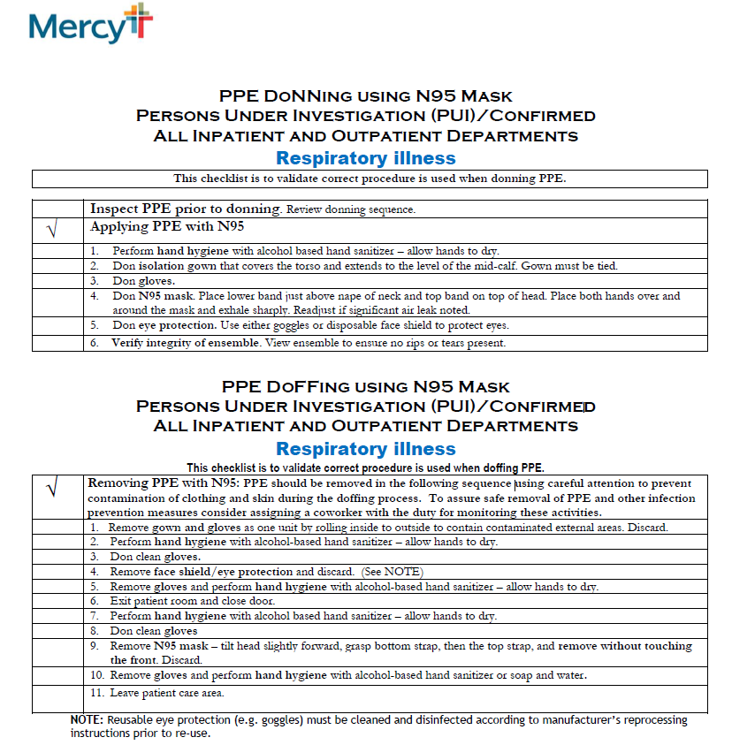

Mercy Testing Center Drive Through Procedures

- Introduction
The purpose of this plan is to guide co-workers operating a Mercy Coronavirus Evaluation Center through the daily operations of the location.

DRIVE THRU PROCEDURES
- Patient Confirmation
  - Patient presents to screening site and is registered
  - Patient confirms identification
  - Coworker retrieves patient label
  - Coworker asks patient for name and date of birth
  - Patient confirms identification information on specimen label
- Specimen Collection
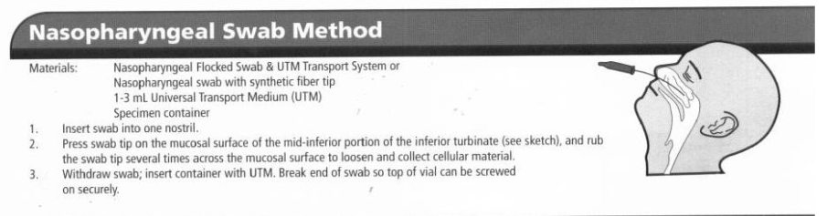
- Patient Information
  - Label Viral Transport Media with patient label
  - Indicate time of collection and collector ID by writing information on patient label
SPECIMEN PROCESSING
- Place specimen in specimen bag (1 sample per bag)
- Place sample into refrigerator for courier to pick-up

TIP: Provide pt with a tissue-swabbing may stimulate gag/cough

